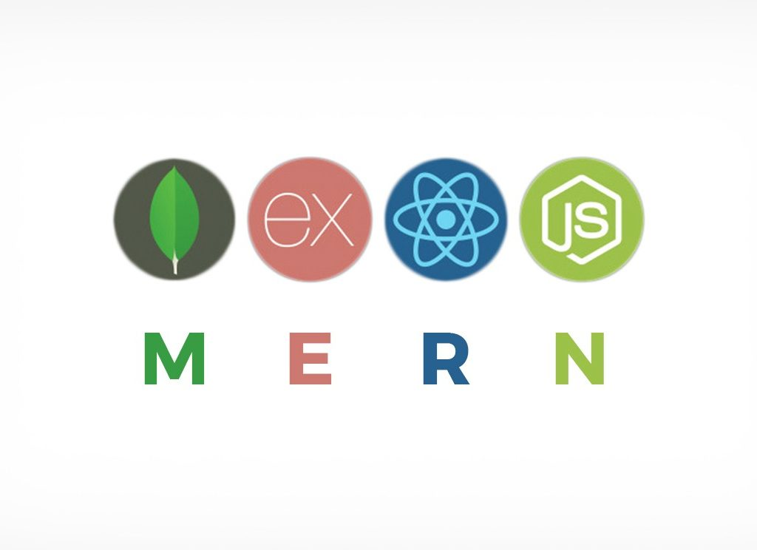

**Prerequisites:**

 Fundamentals of HTML, CSS, and JavaScript

Learn and understand MongoDB , Express js, React js, Node js individual  
before joining to Stack.

**MERN Stack:**

MERN Stack is a Javascript Stack that is used for easier and faster deployment of full-stack web applications. MERN Stack comprises of 4 technologies namely: [MongoDB](https://www.geeksforgeeks.org/mongodb-an-introduction/), [Express](https://www.geeksforgeeks.org/introduction-to-express/), [React](https://www.geeksforgeeks.org/react-js-introduction-working/) and [Node.js.](https://www.geeksforgeeks.org/introduction-to-nodejs/) It is designed to make the development process smoother and easier.

Among these technologies Mongo DB is a database system, Node JS is a back-end runtime environment, Express JS is a back-end web framework and React is a front-end framework.

1.**Mongo DB**

Mongo DB is a free and open-source cross-platform document-oriented database program. Classified as a No SQL database program, Mongo DB uses JSON-like documents with schemata. Mongo DB is developed by Mongo DB Inc., and is published under a combination of the GNU Affero General Public License and the Apache License

**2. Express JS**

Express.js, or simply Express, is a web application framework for Node.js, released as free and open-source software under the MIT License. It is designed for building web applications and APIs. It has been called the de facto standard server framework for Node.js.

**3. React or Redux**

React (also known as React.js or React JS) is a JavaScript library for building user interfaces. It is maintained by Facebook and a community of individual developers and companies.

React can be used as a base in the development of single-page or mobile applications. Complex React applications usually require the use of additional libraries for state management, routing, and interaction with an API.

**Redux** is an open-source JavaScript library for managing application state. It is most commonly used with libraries such as React or Angular for building user interfaces. Similar to (and inspired by) Facebook's Flux architecture, it was created by Dan Abramov and Andrew Clark.

**4. Node JS**

Node.js is an open-source, cross-platform JavaScript run-time environment that executes JavaScript code outside of a browser. Historically, JavaScript was used primarily for client-side scripting, in which scripts written in JavaScript are embedded in a webpage's HTML and run client-side by a JavaScript engine in the user's web browser. Node.js lets developers use JavaScript to write Command Line tools and for server-side scripting—running scripts server-side to produce dynamic web page content before the page is sent to the user's web browser. Consequently, Node.js represents a "JavaScript everywhere" paradigm, unifying web application development around a single programming language, rather than different languages for server side and client side scripts.

**Benefits of MERN stack**

* The MERN stack covers the entire development cycle from Front-end to Back-end using JS.
* It supports MVC architecture for the smooth development process.
* It allows developers to know only JS and JSON for development.
* Has an extensive set of testing tools.
* Has good open-source community support.

Each of these 4 powerful technologies provides an end-to-end framework for the developers to work in and each of these technologies play a big part in the development of web applications.

**Getting started:** First, create a new project folder. Then go to the project folder in command prompt/terminal and type below command to initialize a package.json file. (Make sure npm is installed)

npm init

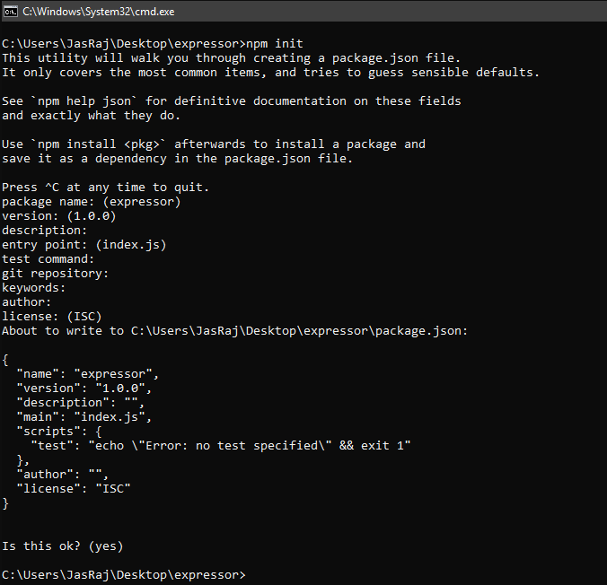

A normal package.json file looks like this:  
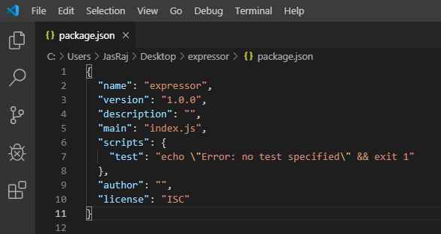

**Note:** Based on your requirements, you can install modules(by typing in **npm install module_name –save**) which will show up in package.json file.

**Getting to know MERN Stack components:**

1. **MongoDB: Cross-platform Document-Oriented Database**  
   MongoDB is a NoSQL database where each record is a document comprising of key-value pairs that are similar to JSON (JavaScript Object Notation) objects. MongoDB is flexible and allows its users to create schema, databases, tables, etc. Documents that are identifiable by a primary key make up the basic unit of MongoDB. Once MongoDB is installed, users can make use of Mongo shell as well. Mongo shell provides a JavaScript interface through which the users can interact and carry out operations (eg: querying, updating records, deleting records).

**Why use MongoDB?**

* + Fast – Being a document-oriented database, easy to index documents. Therefore a faster response.
  + Scalability – Large data can be handled by dividing it into several machines.
  + Use of JavaScript – MongoDB uses JavaScript which is the biggest advantage.
  + Schema Less – Any type of data in a separate document.
  + Data stored in the form of JSON –
    1. Objects, Object Members, Arrays, Values and Strings
    2. JSON syntax is very easy to use.
    3. JSON has a wide range of browser compatibility.
    4. Sharing Data: Data of any size and type(video, audio) can be shared easily.
  + Simple Environment Setup – Its really simple to set up MongoDB.
  + Flexible Document Model – MongoDB supports document-model(tables, schemas, coloumns & SQL) which is faster and easier.

**Example:**

* + **Creating a database: Simply done using a “use” command:**

use database_name;

* + **Creating a table: If the collection/table doesn’t exist then a new collection/table will be created:**

db.createCollection("collection_name");

* + **Inserting records into the collection:**
  + db.collection_name.insert
  + (
  + {
  + "id" : 1,
  + "Name" : "Klaus",
  + "Department": "Technical",
  + "Organization": "Geeks For Geeks"
  + }

);

* + **Querying a document:**

db.collection_name.find({Name : "Klaus"}).forEach(printjson);

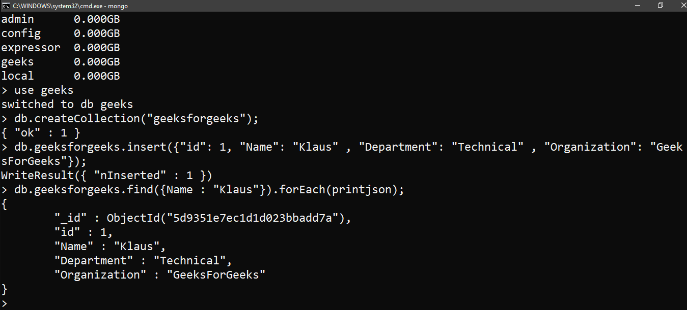

1. **Express: Back-End Framework:**  
   Express is a Node.js framework. Rather than writing the code using Node.js and creating loads of Node modules, Express makes it simpler and easier to write the back-end code. Express helps in designing great web applications and APIs. Express supports many middlewares which makes the code shorter and easier to write.

**Why use Express?**

* + Asynchronous and Single-threaded.
  + Effecient, fast & scalable
  + Has the biggest community for Node.js
  + Express promotes code reusability with its built-in router.
  + Robust API

**Example:** Fololow the below steps:

* + Create a new folder to start your express project and type below command in the command prompt to initialize a package.json file. Accept the default settings and continue.

npm init

* + Then install express by typing the below command and hit enter. Now finally create a file inside the directory named index.js.

npm install express --save

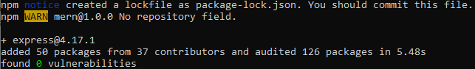

* + Now type in the following in index.js to create a sample server.

filter_none

brightness_4

|  |
| --- |
| const express = require('express'),  http = require('http');    const hostname = 'localhost';  const port = 8080;  const app = express();    app.use((req, res) => {    console.log(req.headers);    res.statusCode = 200;    res.setHeader('Content-Type', 'text/html');    res.end('<html><body><h1>This is a test server</h1></body></html>');    });  const sample_server = http.createServer(app);    sample_server.listen(port, hostname, () => {    console.log(`Server running at http://${hostname}:${port}/`);  }); |

* + Update the “scripts” section in package.json file  
    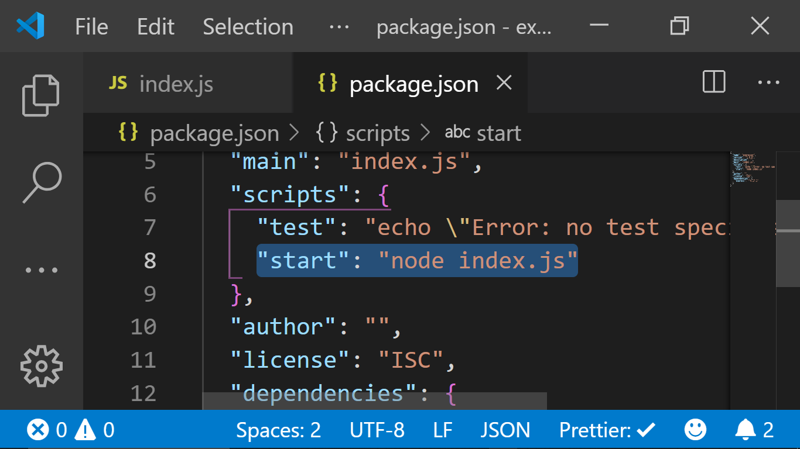
  + Then to start the server by running the below command

npm start

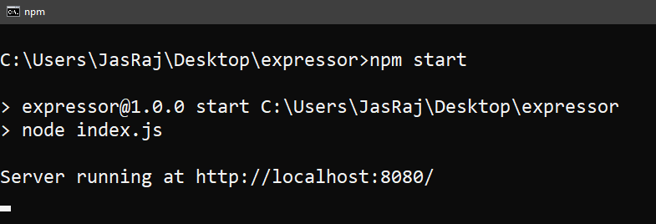

* + Now you can open the broswer and get the output of the running serve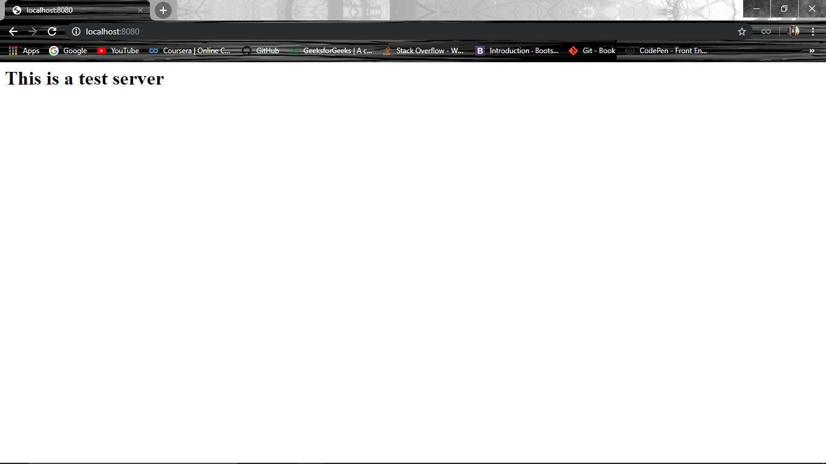

1. **React: Front-End Framework**  
   React is a JavaScript library that is used for building user interfaces. React is used for the development of single-page applications and mobile applications because of its ability to handle rapidly changing data. React allows users to code in JavasScript and create UI components.

**Why use React?**

* + Virtual DOM – A virtual DOM object is a representation of a DOM object. Virtual DOM is actually a copy of the original DOM. Any modification in the web application causes the entire UI to re-render the virtual DOM. Then the difference between the original DOM and this virtual DOM is compared and the changes are made accordingly to the original DOM.
  + JSX – Stands for JavaScript XML. It is an HTML/XML JavaScript Extension which is used in React. Makes it easier and simpler to write React components.
  + Components – ReactJS supports Components. Components are the building blocks of UI wherein each component has a logic and contributes to the overall UI. These components also promote code reusability and make the overall web application easier to understand.
  + High Performance – Features like Virtual DOM, JSX and Components makes it much faster than the rest of the frameworks out there.
  + Developing Android/Ios Apps – With React Native you can easily code Android-based or IOS-Based apps with just the knowledge of JavaScript and ReactJS.
  + You can start your react application by first installing “create-react-app” using npm or yarn.

npm install create-react-app --global

OR

yarn global add create-react-app

* + After that you can create a new react app by using.

create-react-app app_name

Then navigate into the “app_name” folder and type **yarn start** or **npm start** to start your application.  
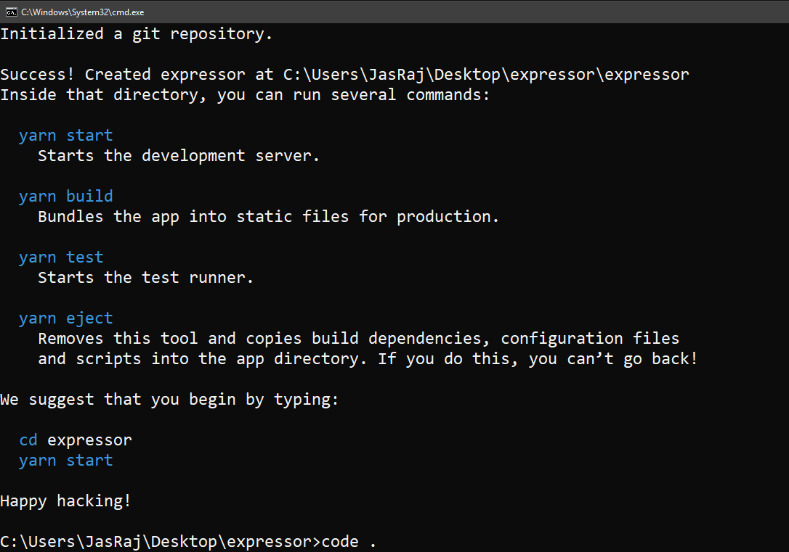

* + A typical React application looks like this:  
    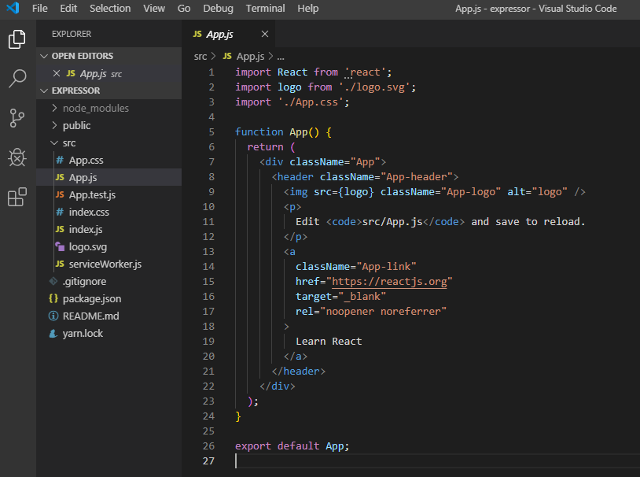

**A small React Example:**

* + Update index.js file

filter_none

brightness_4

|  |
| --- |
| ReactDOM.render(    <h1>Hello DEVELOPERS!!</h1>,    document.getElementById('root')  ); |

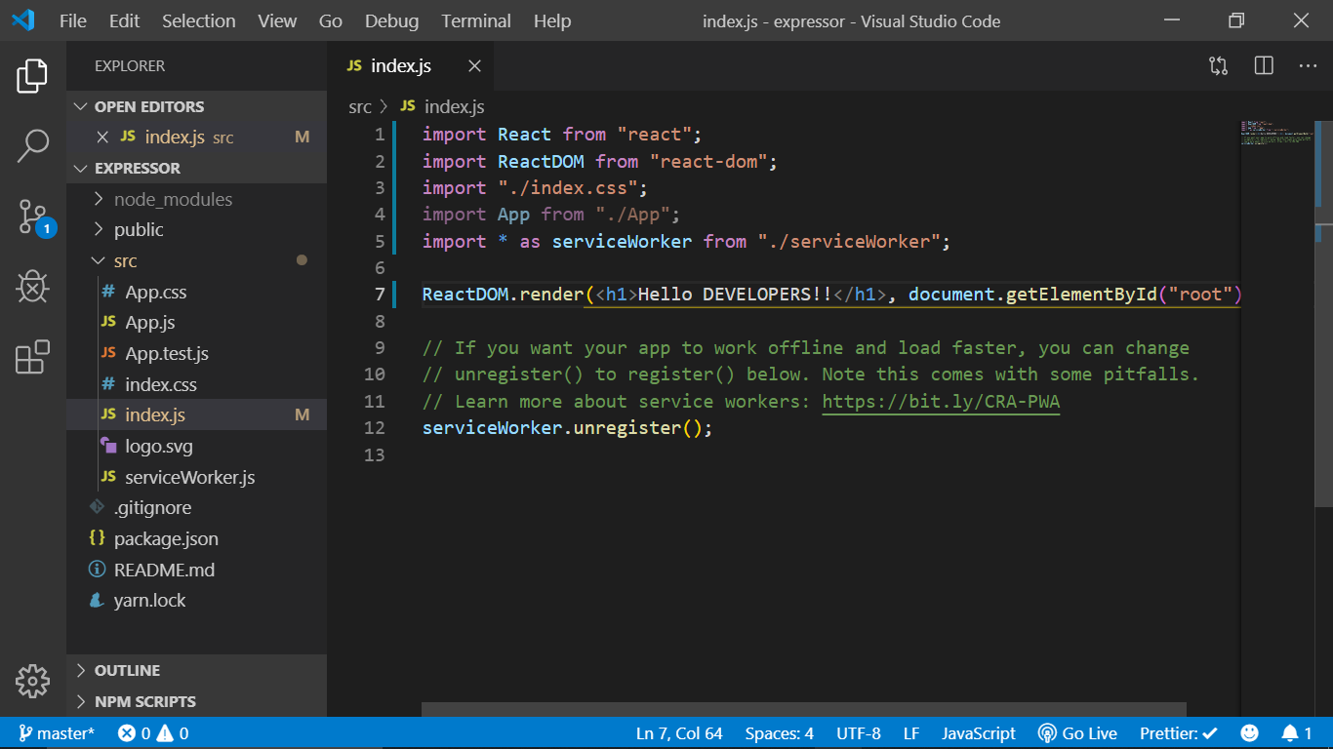

* + Use the below commadns to run your application.

npm start

or

yarn start

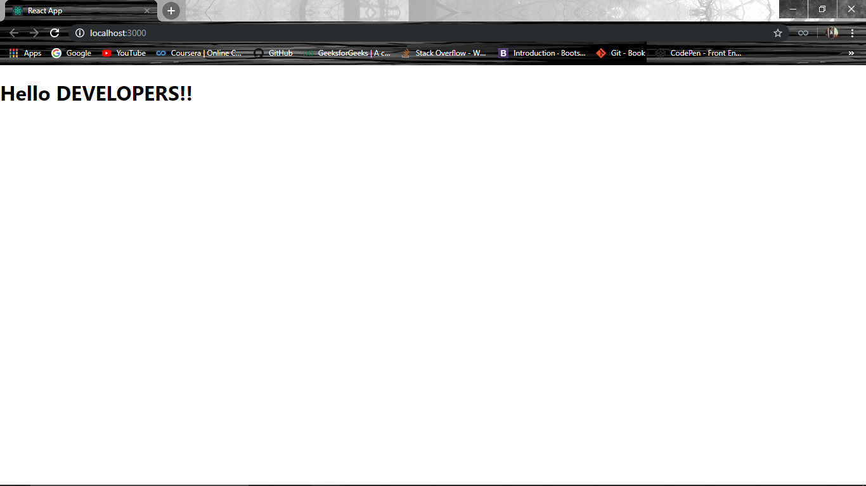

1. **Node.js: JS Runtime Environment**  
   Node.js provides a JavaScript Environment which allows the user to run their code on the server (outside the browser). Node pack manager i.e. npm allows the user to choose from thousands of free packages (node modules) to download.

**Why use Node.JS?**

* + Open source JavaScript Runtime Environemnt
  + Single threading – Follows a single threaded model.
  + Data Streaming
  + Fast – Built on Google Chrome’s JavaScript Engine, Node.js has a fast code execution.
  + Highly Scalable
  + Initialize a Node.js application by typing runing the below command in the command window. Accept the standard settings.

npm init

* + Create a file named index.js.  
    **Example:**  
    A basic Node.js example to compute the perimeter & area of a rectangle.

filter_none

brightness_4

|  |
| --- |
| var rectangle = {      perimeter: (x, y) => (2*(x+y)),      area: (x, y) => (x*y)  };    function Rectangle(l, b) {      console.log("A rectangle with l = " + l + " and b = " + b);        if (l <= 0 || b <= 0) {          console.log("Error! Rectangle's length & breadth should be greater than 0:  l = "                 + l + ",  and b = " + b);      }      else {          console.log("Area of the rectangle: " + rectangle.area(l, b));          console.log("Perimeter of the rectangle: " + rectangle.perimeter(l, b));      }  }    Rectangle(1, 8);  Rectangle(3, 12);  Rectangle(-6, 3); |

* + Run the node application by running the below command in the command window.

npm start

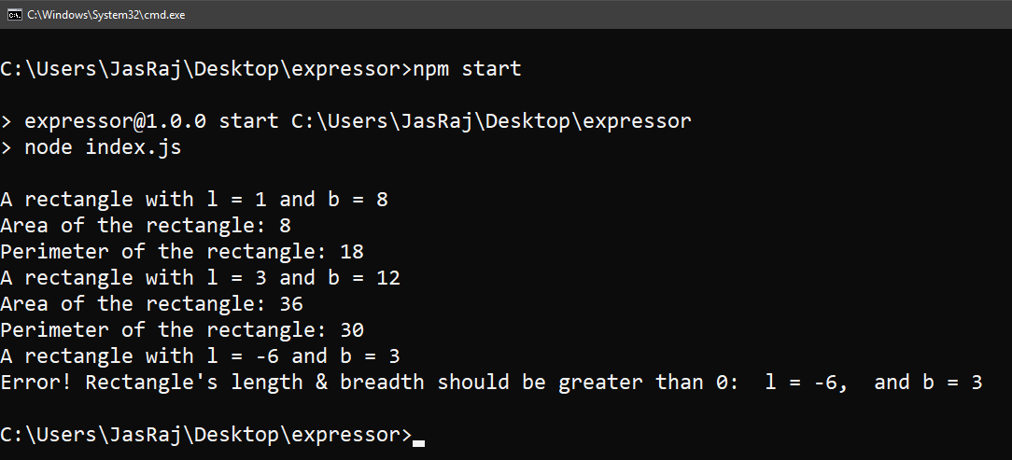

**DIFFERNENCE BETWEEN MEAN AND MERN:**

**MEAN Stack**

The term “**MEAN Stack**” stated as a set of collected JavaScript-based technologies used to develop complex websites and web apps(progressive or responsive). In simple words, MEAN, as explained as a full-stack JavaScript framework — which simplifies and accelerates web & application development.

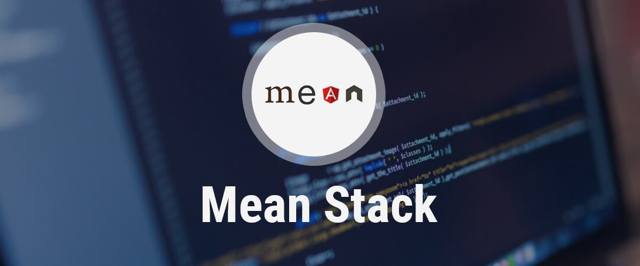

MongoDB, Express.JS, Angular, and Node.JS are a group of technologies that make a combination of MEAN Stack technology in Mobile and Web Applications. In recent time, some of the complex websites & web apps(responsive) are powered by MEAN Stack.  
MEAN Stack is one of the fastest growing open source stack development framework assists developer or teams with popular tools or plugins to reduces the time on system administration and it also allows the quicker deployment of web apps, websites and API’s to concentrate on the complex development process of your project.

1. **MongoDB**: Document database — used by your back-end application to store its data as JSON (JavaScript Object Notation) documents
2. **Express (sometimes referred to as Express.js):** Back-end web application framework running on top of Node.js
3. **Angular (formerly Angular.js, now also known as Angular 2):** Front-end web app framework; runs your JavaScript code in the user’s browser, allowing your application UI to be dynamic
4. **Node.JS:** JavaScript runtime environment — lets you implement your application back-end in JavaScript

#### **Benefits Of Choosing MEAN Stack:**

* Covers the full web development cycle from front end development (client side) to back end development (server side) using JavaScript.
* Supports the MVC(Model View Controller) architecture to make the development process flow smoothly.
* Helps to resist unnecessary [grunt](https://en.wikipedia.org/wiki/Grunt_%28software%29) work, thus keeping the web application development much organized.
* The merger of four great technologies, i.e., MongoDB, Express.JS, Angular.JS, and Node.JS.
* Comes with a pre-built extensive suite of testing tools.
* Open source in frameworks and backed by good community supports.

### **What is MERN stack and why to choose?**

MERN Stack, a combination of technologies used to craft premium web apps. Web apps are developed using multiple technologies more likely to say frameworks, libraries, databases and more. The MERN stack is a JavaScript stack used for the smooth flow of the development process. MERN consists of different open-source components: MongoDB, Express, React, and Node.js. All the components provide the end-to-end framework support for developers to work in.

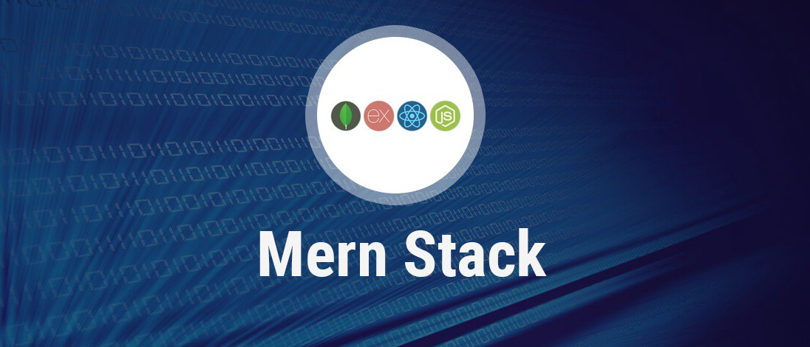

The MERN stack is becoming increasingly popular and is a powerful stack to work in. The “**MERN stack**” refers to the following technologies as follows:

1. **MongoDB**: A document-based open source database
2. **Express**: A Fast, unopinionated, minimalist web framework for Node.js
3. **React**: A JavaScript front-end library for building user interfaces
4. **Node.js**: Node.js is a JavaScript runtime built on Chrome’s V8 JavaScript engine. Node.js brings JavaScript to the server

The MERN stack is very similar to MEAN stack. The only difference here is that the MEAN stack is making use of Angular to build the front-end web application but in the MERN stack is using React instead.

#### **Benefits Of Choosing MERN Stack:**

* Covers the full web development cycle from front end development (client side) to back end development (server side) using JavaScript.
* Supports the MVC(Model View Controller) architecture to make the development process flow smoothly.
* With the JavaScript stack, developers only need to be proficient in JavaScript and JSON.
* Feasibility of four best technologies, i.e., MongoDB, ExpressJS, React, and NodeJS.
* Comes with a pre-built extensive suite of testing tools.
* Open source in frameworks and backed by good community supports.